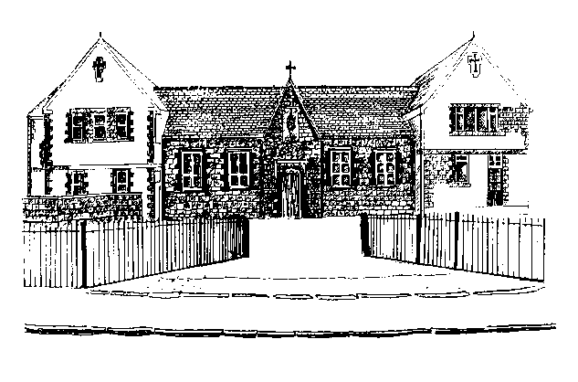
St.John the Baptist Aided School
St.John the Baptist Aided School
Chester Road
Penymynydd
Nr. Chester
Flintshire
CH4 OEN
Tel/Fax: 01244 550838
jbmail@st-johns-pri.flintshire.sch.uk
www.stjohnsflintshire.org
Ysgol Sant Ioan y Bedyddiwr
Ffordd Caer
Penymynydd

Ger Caer
Sir Y Flint
CH4 OEN
Ffôn/Ffacs: 01244 550838
jbmail@st-johns-pri.flintshire.sch.uk
www.stjohnsflintshire.org
Pentrobin
Mrs A Stephens
Headteacher

17th May 2016

Dear Parents/Guardians

Re: Festival of Youth Sports 2016

Your child has been chosen to participate in this years ‘Festival of Youth Sport 2016’ which is to be held on Thursday 26th May at Deeside Leisure Centre. We shall be participating in the 5 A-side football event.

The event will run from 9.30am until 12.00. Therefore, we are asking parents to arrange for their child to be dropped off at Deeside Leisure Centre in the morning. Children will need to be dropped off at 9.10a.m. at the 3G pitches which are located behind Deeside Leisure Centre. Please ensure your child is handed over to Miss Thelwell.

The school have arranged for a minibus to bring the children back to school at lunchtime after the event has finished.

The children will need a packed lunch, plenty to drink (no fizzy drinks or glass bottles) and a snack (no sweets please). They will need to wear their P.E. kit, trainers and bring a waterproof jacket/coat.

Please complete Form D (on the reverse of this letter) and the slip below as soon as possible.

Yours sincerely

Mrs Betts and Miss Thelwell

___________________________________________________________________________________________

Festival of Youth Sports 2016 – Thursday, 26th May 2016

My child _______________________________________ will be able to attend the event.

Signed ____________________________(parent/guardian)

