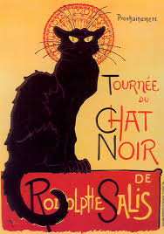
Comment ça va ? 10.06.16
French Club coming to Saint John the Baptist VA Primary School.

Dear Parents / Guardians.

I am a qualified primary school teacher and a fluent french speaker. I plan to start a French Club at Saint John the Baptist V.A Primary School in September 2016.
‘Saint Jean Le Baptiste, Club Français ’

Learning a new language is enjoyable and expands the mind! You‘ll get a flavour of a new culture and even sample some french cuisine. My sessions are fun, well paced and interactive. I offer exciting learning experiences using songs, games, crafts, role play, drama, speaking and listening activities galore.

The sessions will follow the Department for Education and Skills “Framework for Language” to ensure continuity and progression. Free vocabulary lists / worksheets and recommended online resources will be provided to support your child’s learning.

Come and give French club a try.

Yours Faithfully
Miss Joanne Pickstock

Infants 12.25-12.55pm Monday ... Lunch time club (Small group max 10 pupils)
Juniors 3.15-4.15 pm Monday... After school Club (Larger group max 20 pupils ........but longer session)
Cost £4.80 per session, paid each 1/2 term in advance.

Please return consent form to school by Friday 8th^{th} July
.............................................................................................................................................................

I would like my child to Join French club in September

Child’s Name....................................................... Year group..........................

E-mail.....................................................................

For further information please contact me via

E-mail pickstockjo@yahoo.com or Tel. 01244 530 500

