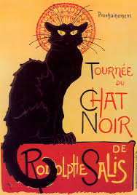
Comment ça va ? 14.01.19

French Club at Saint John the Baptist VA Primary School.
Dear Parents / Guardians.

I am a qualified primary school teacher and a fluent French speaker. I currently run 3 classes at Saint John’s for the Infants, Juniors and recently offered Reception children the opportunity to learn French too.

The Reception session will take place on Mondays during the afternoon break 2.15-2.35pm with a short play outside before returning to class. This will be held in the children's Reception classroom.

Learning a new language is enjoyable and expands the mind!! You‘ll get a flavour of a new culture and even sample some French cuisine. My sessions are fun, well paced and interactive. I offer exciting learning experiences using songs, games, crafts, role play, drama, speaking and listening activities galore.

The sessions will follow the Department for Education and Skills “Framework for Language” to ensure continuity and progression. Free worksheets and recommended online resources will be provided to support your child’s learning.

If your child would like to come and try French club please sign up or email me details below . If your child likes French Club and wishes to continue I will send out the payment details.

Yours Faithfully Miss Joanne Pickstock

Infants 12.25-12.55pm Monday Lunch time club (Small group max 10 pupils)
Juniors 3.15-4.15 pm Monday After school Club (Larger group max 20 pupils ........but longer session) Cost £4.80 per session, paid each 1/2 term in advance.

Reception 2.15-2.35pm £4.00 per session, paid each 1/2 term in advance.
.............................................................................................................................................................
I would like my child to Join French club

Child’s Name....................................................... Year group..........................

E-mail..................................................................… Mobile..............................

For further information please contact me via

E-mail pickstockjo@yahoo.com

