St. John the Baptist
V.A. School

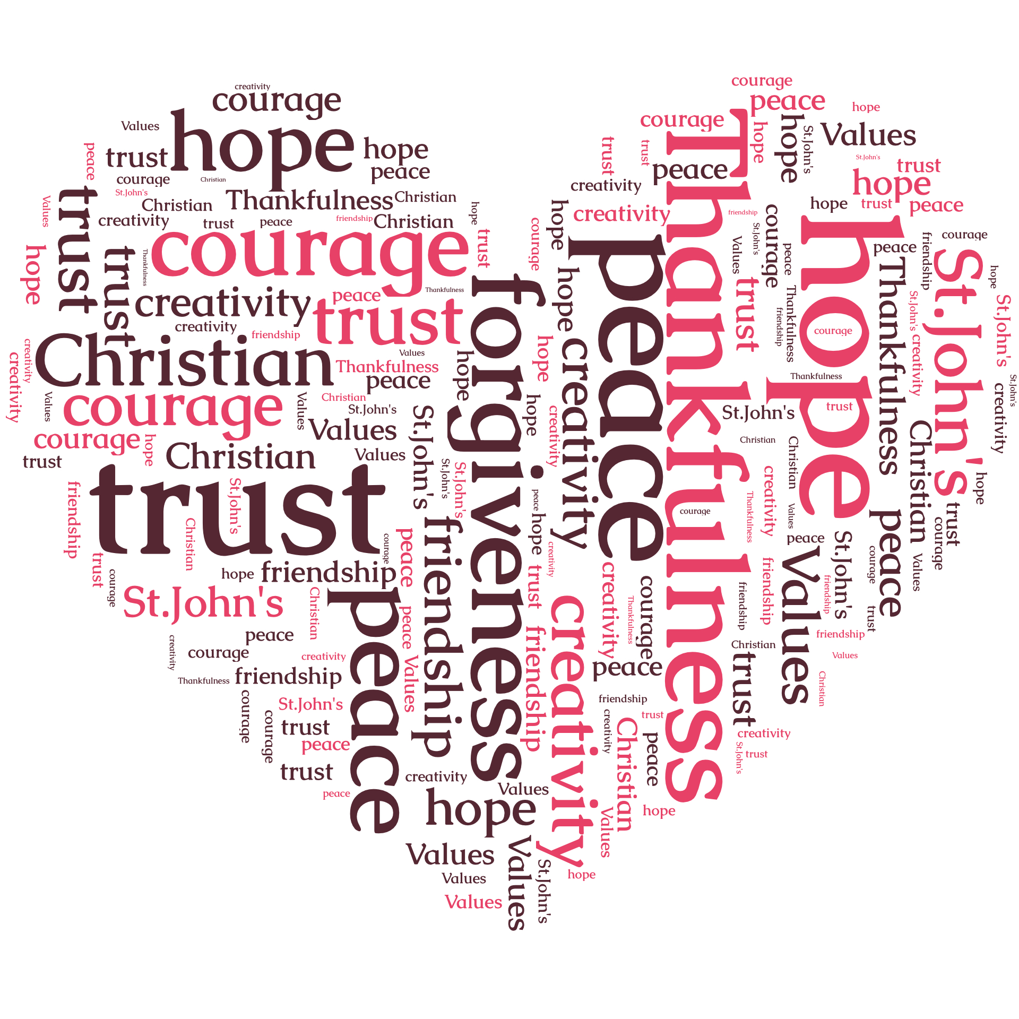

Handwriting Policy

“Working together to achieve our best in a caring Christian school”

Introduction

A child’s ability to write comfortably, legibly and speedily affects performance across the curriculum and can also have an effect on pupils’ self esteem. Children are therefore encouraged to understand the benefits of achieving fluency and legibility in handwriting. They should also be taught that handwriting is an important aspect of the presentation of written work.

Entitlement

All children are entitled to access the Programmes of Study for handwriting detailed in ‘English in the National Curriculum in Wales’ (ACCAC, 2000).

Implementation

The implementation of the Handwriting Policy is the responsibility of all teachers.

Foundation Phase

In order that children can eventually acquire a fluent, legible and efficient handwriting style they need to develop skills including:

- Good gross and fine motor control
- A recognition of pattern
- A language to talk about shapes and movements

The development of gross and fine motor skills in the Foundation Phase is provided for and documented in the Physical Development and Language, Literacy and Communication Areas of Learning from the Foundation Phase Framework (Welsh Assembly Government 2008). Play activities and particularly those involving manipulation provide many opportunities for the development of fine motor skills. Until children have gained reasonable fine motor control through art and other play activities formal handwriting worksheets are not used.
Pre –writing skills are developed by the introduction of a range of writing, drawing and painting tools and from the earliest stages emphasis is placed on helping children to hold pencils correctly and on developing appropriate posture and writing position.
At the annual meeting for parents of pre-school children, parents are provided with suggestions for activities at home which support the development of fine –motor and handwriting skills.

Posture and pencil grip

It is essential for children to develop good posture and pencil grip from the earliest stages. As the amount of time spent by pupils in writing increases throughout the years, sitting in an awkward position can cause headaches and fatigue or pain in the shoulder arm or hand. Poor posture and/or pencil grip can also slow down a child’s writing. To ensure the development of good posture and pencil grip, the following points are considered by all staff:

- The height of tables and chairs is appropriate so that children can sit comfortably, with feet flat on the floor. Legs should not come into contact with the underside of the desk/table top. Children should be able to sit up at the table without having to lean over it or stretch to reach it.
- Children are seated at tables with sufficient space around each pupil.
- Lighting is good so that children can see what they have written.
- All children have a direct view of the teacher and the board.
- Children are shown how to use their non-writing hand to steady the paper and bear some body weight.
- Paper should be tilted slightly.
- A good pencil grip is one which is relaxed but allows for efficient control of the pencil.If children grip a pencil too tightly, they will not develop a free-flowing movement and they may tire very quickly. Children are taught to hold the pencil between thumb and forefinger with the pencil resting on the third finger. The thumb and forefinger should also be able to move slightly so that very fine movements required for writing are possible.
- Pencil grip is taught, re-enforced and checked by all staff; commercial pencil grips and /or triangular pencils may be used only if other methods have failed .

Formation of letters

- The agreed style of letter formation is provided in the attached sheet. Nelson handwriting groups the letters into sets based on handwriting families. These are letters that are formed in similar ways.

The four groups sets are :
- Set 1 - Anti-clockwise round : key letter c ( curly caterpillar) –
letters c, a, o, g, d, q, e, f, s
- Set 2 - Down and off in another direction : key letter l ( long ladder) –
letters i, j, l, t, u, y
- Set 3 - Down and retrace upwards : key letter r ( one-armed robot) –
letters r, n, m, p, h, b, k
- Set 4 - Zig –zag letters : key letter – v –
letters v, w, x, z

2. Each letter is introduced in association with its key letter. NB b and d are in separate groups of letters to assist with discrimination of these easily-confused shapes.

3. The majority of letters either have a ‘natural’ exit stroke e.g. c, f or are taught with the inclusion of an exit stroke from the beginning e.g. a, d, h, I, k, l, m

4. The joining point of remaining letters is taught as children demonstrate readiness to join letters (see ‘Joining of Letters’ below).

5. By the end of the foundation phase the expectation for most pupils is that letters are correctly formed and appropriately sized and spaced. Ascenders and descenders should also be correctly used.

Joining of letters

- Joining of letters is introduced as soon as possible either in the foundation phase or at key stage 2 once children are secure in the movement, formation, size and spacing of individual letters .
The going groups divide the letters according to how they will join to other letters.

Group 1
a c d e h I k l m n s t u

Thirteen letters with exit flicks plus s

Group 2
a c d e g i j m n o p q r s u v w x y

Nineteen letters which start at the top of the x-height

Group 3
b f h k l t

Six letters which start at the top of the ascender.

Group 4
f o r v w

Five letters which finish at the top of the x-height.

The break letters
b g j p q x y z

Eight letters after which no join is made. Joins are not made to or from the letter z.

Writing materials and implements

- In the foundation phase a range of writing tools are provided in play and drawing contexts, including pencils, marker pens, finger paints and paintbrushes.
- In Key Stage 1 and lower Key Stage 2, pencils are used for routine classwork.
- Pens are introduced once a fluent joined style is well established: for most pupils this should be during Y3/Y4 . The use of ball-point pens is not permitted. The general expectation is that most pupils will use fine-fibre pens.

- From the earliest stages pupils are taught the position of individual letters in relation to a line.

With very few exceptions children progress to lines of decreasing width-spacing as follows :

Year | Line spacing
Reception | 15mm
1 | 10mm
2 | 10mm
3 | 8mm
4 | 8mm
5 | 8mm
6 | 8mm

Provision for left-handed pupils

At least 10 per cent of the population is left-handed ; a slightly higher proportion of males is an added feature of this group . The following strategies are employed to ensure that left-handed children are not disadvantaged when writing :

- In the foundation phase all modelling of letter formation e.g. sky writing etc. is repeated specifically for left-handed children, the teacher using his/her left hand.
- Left-handed children are seated on the left of right-handed children to avoid any clashing of writing arms.
- In the foundation phase a mark may be put at the left hand side of the page to indicate where writing begins, to counter a tendency to mirror-write from the right.
- Left-handers are shown how to position their paper slightly to the left of centre of their body and are encouraged to tilt their work clockwise so that they can see what they have written.
- Seat height is checked ; some left-handed children may require a higher seat in order to view their work clearly and to prevent the elbow locking into their side as they work across the paper.
- To avoid smudging their work left-handed children are encouraged to position their fingers about 1.5cm away from the end of their writing implement. They may also prefer to use a fine -fibre or rollerball pen.

Classroom Management and Organisation

Teachers may employ a balance of whole class, group and individual teaching, according to the needs of their particular class. For whole class and group teaching, furniture and/or children’s seating positions may need to be re-organised to ensure that all pupils have a clear view of the teacher and of the board used for demonstration.

Handwriting and Presentation

All pupils are taught that handwriting is an important feature of presentation. In Key Stage 2 particular attention is paid to handwriting in the final draft of written work and wherever there is a wider audience for writing.

Additional Learning Needs

Where a specific difficulty with handwriting is identified a detailed assessment is available for use by the class teacher. Following assessment, an individualised programme will be provided as appropriate .

Pupils transferring from other schools

In the case of pupils transferring from other schools in which a different style of handwriting has been taught, the class teacher will assess the pupils’ handwriting and a decision will be made as to whether or not the pupil should continue with this style. Factors to be taken into account will include the age of the pupil and the extent to which a fluent, joined and legible style has already been established.
Assessment

All staff assess pupils’ handwriting as part of each term’s Writing Assessment. Samples of work are retained and may form part of the Literacy Portfolio. Pupils will be made aware of handwriting expectations on their marking ladder which will detail the handwriting success criteria. Where there is any cause for concern more detailed assessment will be undertaken (see ALN above).

Handwriting Expectations

Indicated below are expectations within year groups for the majority of pupils. Pupils with additional needs will work to individual targets to develop handwriting skills.

It is essential that all staff recognize the stage of development of each pupil and provide appropriate activities and practice to ensure that pupils can work towards the next stage.

Reception | Hold writing instruments appropriately  Write from left to right  Discriminate between letters.
Year 1 | Form upper and lower-case letters that are usually clearly shaped and correctly orientated.
Year 2 | Form upper- and lower-case letters accurately and with consistent size.
Year 3 | Produce legible handwriting and present work appropriately joining letters in some words.
Year 4 | Produce handwriting which is clear and legible and may be cursive. As joining becomes more fluent, a proportion of the class should be using a pen for most writing by Christmas. The majority should be using a pen by the end of the summer term.
Year 5 | Produce legible, cursive handwriting with increasing fluency. Pupils will be encouraged to use a pen for nearly all written work.
Year 6 | Produce fluent and legible handwriting. Pupils should be developing a sense of personal style.

Monitoring and Review
Author | Miss E Thelwell
Originally Created | April 2016
Last updated
Approved by | Curriculum Sub-Committee
Approved on | 28th June 2016
Adopted by Full Governing Body on | June 2016
Scheduled review date | Summer term 2017
Head teacher’s signature and date
Chair of Governor’s signature and date

