St. John the Baptist
V.A. School

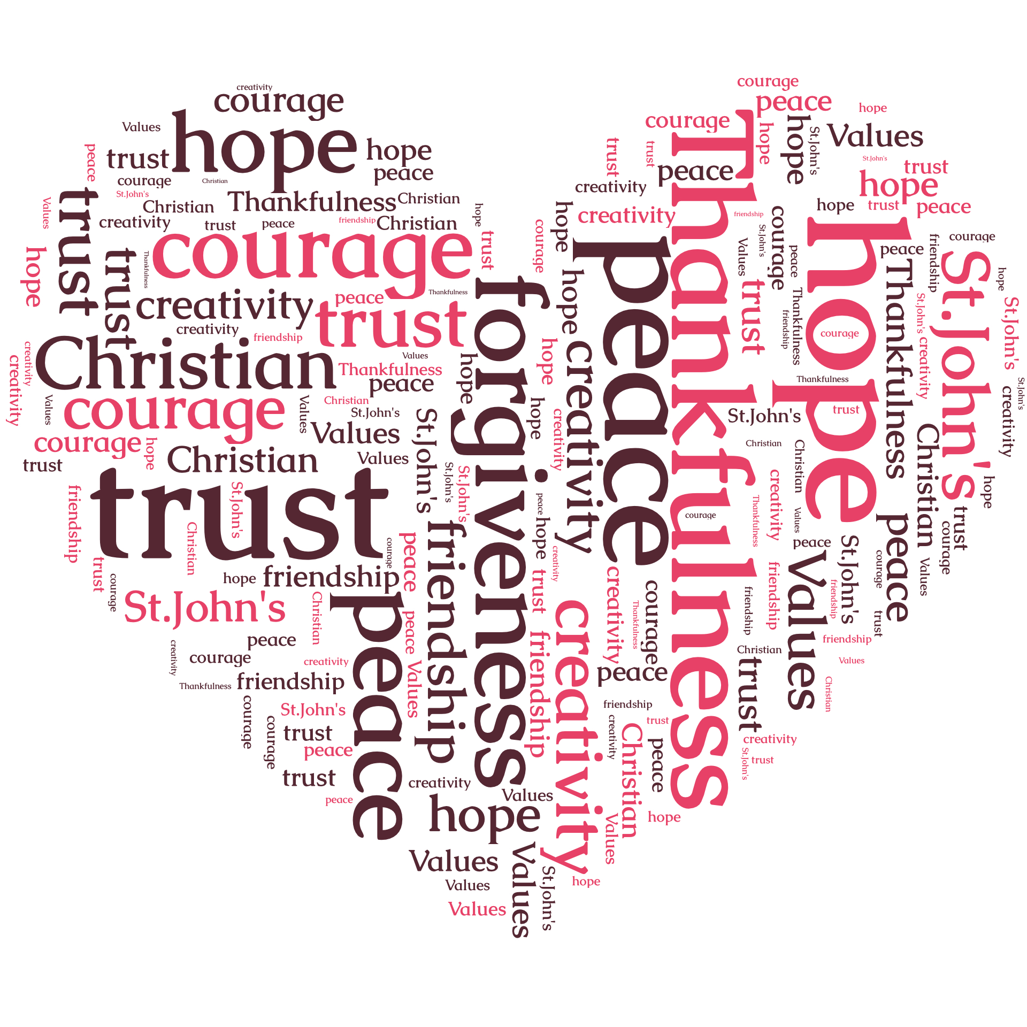

Anti-bullying Policy

“Working together to achieve our best in a caring Christian school”

Anti bullying statement
Aims
It is a fundamental aim of our school that our children should feel happy and safe. The school follows the 1998 Human Rights act in which we aim to treat everyone equally, with fairness, dignity and respect.
Therefore we do not tolerate bullying behaviour.

Definitions of bullying

We define bullying behaviour in the following way:
- deliberately hurtful (including aggression)
- repeated often over a period of time (while recognising that even a one-off incident can leave a learner traumatised and nervous of future recurrence)
- difficult for victims to defend themselves against.
Bullying can take many forms, but the three main types are:
- physical – hitting, kicking, taking belongings, sexual harassment or aggression
- verbal – name calling, insulting, making offensive remarks
- indirect – spreading nasty stories about someone, exclusion from social groups, being made the subject of malicious rumours, sending malicious e-mails or text messages on mobile phones or through social media and online gaming.

Bullying may focus on the differences between people. We do not tolerate bullying which focuses on the following:

- Bullying around race, religion and culture
- Bullying around special educational needs and disabilities
- Homophobic bullying
- Sexist, sexual and transphobic bullying
- Cyberbullying

We aim to Prevent Bullying in the following ways:
Through our behaviour policy
This anti bullying policy is part of our wider behaviour policy which includes the rewards and sanctions which we use to promote good behaviour in our school. Through our school rules we are specific with children about the behaviours we which wish to encourage and those behaviours which are unacceptable.

Through the curriculum
It is our aim both to protect the victims and to educate those children who demonstrate bullying behaviours. Our personal and social education programme is designed to teach children how to live and work together in school in a kind and supportive way. We aim to generate tolerance and an appreciation of difference through our personal and social education programmes and particularly by the values we share with children in circle time, assemblies and through the culture of the school.

By promoting pupil voice
We want our children to know that their voice will be heard. We establish this principle in the following ways.
  - The school council members elected by their peers are involved in school decision making.
  - Children taking responsibility within the school in various roles including house captains, friendly faces, librarians and eco committee.
  - Children making decisions about their learning and reflecting on their own and others’ work.

Procedures to be followed when bullying has taken place.
- When bullying is observed in school, staff will follow the hierarchy of sanctions in the behaviour policy.
- When bullying is reported by a child, staff will believe the child and offer reassurance. They will investigate the incident and apply the schools hierarchy of sanctions, giving the child who has demonstrated bullying behaviours the opportunity to make amends.
- When bullying is reported by parents, staff will investigate the incident, apply the behaviour policy and report back to parents.
- The head keeps a record of incidents and asks parents to come back to school if the incident recurs or if their child continues to be unhappy in school.
- When the schools sanctions are not effective the head will involve the parents of the bullying child and in extreme cases consider exclusions.

Roles and responsibilities
- All adults who work in the school should be vigilant in preventing and dealing with bullying.
- Teachers will deal with incidents in their classroom or at playtime as they occur.
- Lunchtime staff keep a record of persistent behaviour which is reported to teachers.
- In a case where a child is showing signs of anxiety at home or at school senior staff will be immediately involved in investigating and responding.

Responsive monitoring of bullying behaviour

- Senior staff maintain a log of issues as they arise from parents, staff and children. They record the action taken and advice given.
- Patterns of behaviour are monitored so that common issues can be addressed across the whole school through the circle time programme.
- The Monday morning briefing has a wellbeing item so that all staff will know the names of children who are vulnerable or in need of special support or monitoring. (details are not shared with everyone)

Impact of bullying
We recognise that children may be badly affected by bullying and need the support and understanding of staff for a period afterwards.

We also recognise that some children are more vulnerable to bullying. These children may need a buddy or particular adult to support at playtime and lunchtime for a period of time.

Some children may need support with developing social skills to aid their interaction with others. In these cases we offer small group support according to need. This may take the form of small circle times focussing on particular needs or social/nurture groups focussing on self esteem and social skills.
Welsh Government report
“Research shows that policies that have gone through consultation with the whole school community are most effective.”

Monitoring and Review
Author | Mrs A Stephens
Approved by | Curriculum Sub-Committee
Approved on | 7th November 2016
Adopted by Full Governing Body on | 8th November 2016
Scheduled review date | Autumn term 2018
Head teacher’s signature and date | Mrs A Stephens  07.11.16
Chair of Governor’s signature and date | Mrs H Darymple  07.11.16

